**Pipe Support Verifier User Guide**

**Introduction**

This guide provides instructions on how to use the Pipe Support Verifier application to verify pipe support tags in AutoCAD drawings using data from Excel files.

**System Requirements**

Before using the application, ensure that your system meets the following requirements:

* **Windows 10/11 (64-bit)**
* **AutoCAD 2018 or newer** installed and running
* **Microsoft Excel 2010 or newer**

No additional software installations are required, as everything is bundled within the application.

**Getting Started**

1. 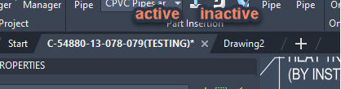**Launch the Application**  
   Double-click on the Pipe Support Verifier executable file to open the program. Make sure your AutoCAD drawing with pipe supports tags is open and active before proceeding.

### ****Step 1: Load the Drawing and Excel File****

1. **Browse for the Excel File**  
   Click on the **Browse file** button to select the Excel file that contains the pipe support data. This Excel file should be properly formatted with the relevant SD-TAGs for verification. The full path to the Excel file should appear as shown below.

### 

### ****Step 2: Check the Tags****

1. **Verify the Tags**  
   Click the **Check tags** button to compare the load tags in your drawing with the SD-TAGs in the Excel file. This will let you know if the tags match or if there are any discrepancies that need to be addressed. The process may take a moment depending on the number of tags, and a progress bar will show the current status of the check.



The process may take a moment depending on the number of elements on your drawing, and a progress bar will show the current status of the check.

There is a way to avoid delays when working with the application – since the app needs to read data from each item on your drawing to find needed blocks, try not to have exploded blocks that came from equipment model. This can increase the number of items several times.

1. **Review the Results**

* Once the check is complete, a detailed report will be displayed at the bottom of the application. The report will summarize the following:
  + **Correct load + SD-tags**: Tags that match both load and SD-TAGs.
  + **Possible to fill SD-tags**: Tags that are ready to be filled based on the Excel data.
  + **Waiting for load tags**: Any load tags missing from the AutoCAD drawing.
  + **Waiting for SD-tags**: SD-TAGs that were expected but not found in the Excel file.
  + **Wrong load tags**: Tags that don’t match or contain errors.

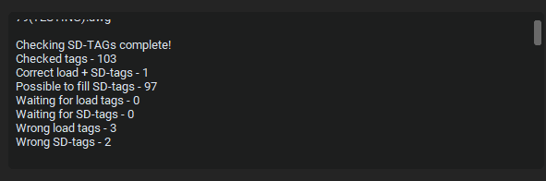

### ****Step 3: Fill the Tags****

1. 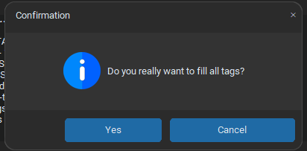**Enable the Fill Tags Feature**  
   The **Fill tags** button will only be enabled after you have successfully checked the tags. Once it's available, click the **Fill tags** button to automatically fill in the SD-TAGs in your AutoCAD drawing and answer “Yes” in the “Confirmation” window.

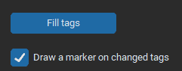

1. **Optional: Mark Changed Tags**  
   Please be aware that by default, the checkbox   
   **“Draw a marker on changed tags”** is selected. This will place a marker (Circle with cyan color)  
   next to any updated or modified tags in the drawing.

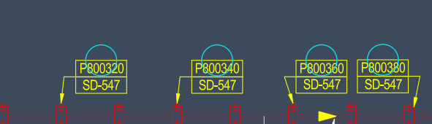

### ****Step 4: Export the Report to Excel****

1. 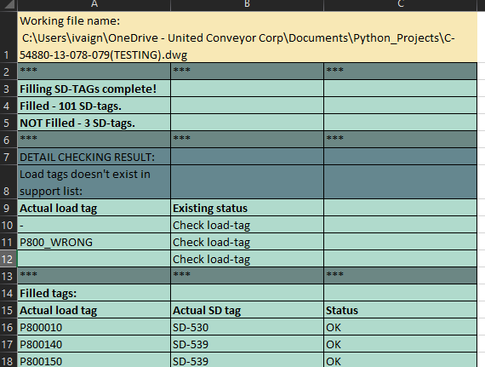**Export the Report**  
   After checking or filling tags, the button **“Export to .xlsx” becomes available.** Click the button to generate a report in Excel format. This report will summarize the results of the tag verification or filling process.



### ****Troubleshooting****

* **If the AutoCAD drawing doesn't load**: Ensure that AutoCAD is open and the correct drawing file is selected.
* **If the Excel file is not recognized**: Verify that the file is properly structured and includes the correct SD-TAG data.
* **If blocks are not found**: Ensure that the block names and attributes in the AutoCAD drawing match the ones in the Excel file.

### ****Support****

For any issues or questions regarding the Pipe Support Verifier application, please contact our support team at **ivanignatenko@uccenvironmental.com**.